1.Go through this program and write a comment above each line explaining it.

Output:

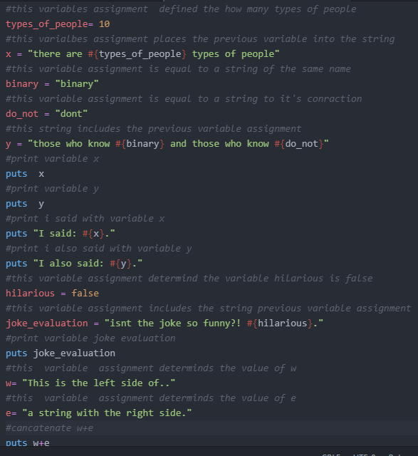

2.Find all the places where a string is put inside a string.



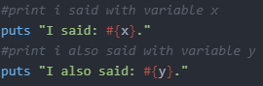

3.Are you sure there are only four places? How do you know? Maybe I like lying.

Totally there are 9 strings in this program. Those are variables, and those variables are also strings.4 of the strings include variables that are also srings.

4.Explain why adding the two strings w and e with + makes a longer string.

The process of “adding” the two strings is called concatenating

5.What happens when you change the strings to use ' (single-quote) instead of " (double-quote)? Do they still work? Try to guess why.

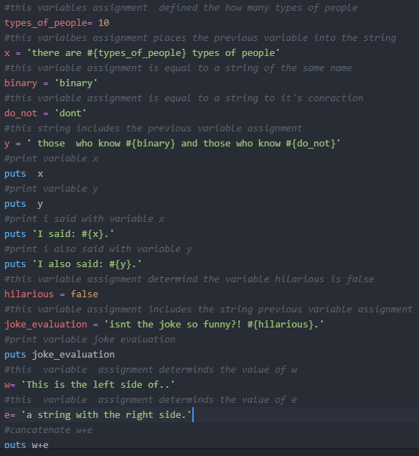



Double quotes are used to produce strings single quotes applied to print a single string, but not a string with multiple strings